1

LOW LEVEL DESIGN

**Table of contents**

| 1. | Introduction__________________________________________________________ | 02 |
| --- | --- | --- |
|  | 1.1 Purpose __________________________________________________________ | 02 |
|  | 1.2 Reference________________________________________________________ | 02 |
| 2 | Scope ______________________________________________________________ | 02 |
|  | 2.1 Out of Scope ______________________________________________________ | 02 |
|  | 2.2 Assumptions ______________________________________________________ | 02 |
| 3 | Details of Binaries_____________________________________________________ | 02 |
| 4 | Class Details__________________________________________________________ | 03 |
|  | 4.1 Class details Tables_________________________________________________ | 03 |
| 5 | Activity diagram______________________________________________________ | 05 |
|  | 5.1 Admin Module_____________________________________________________ | 06 |
|  | 5.2 Customer Module__________________________________________________ | 07 |
|  | 5.3 Donor Module_____________________________________________________ | 08 |
|  | 5.4 Hospital Module___________________________________________________ | 09 |
| 6 | Configuration files_____________________________________________________ | 10 |
| 7 | Limitations and Notes__________________________________________________ | 10 |
| 8 | Revision history of the work product ______________________________________ | 10 |
|  |  |  |
|  |  |  |
|  |  |  |
|  |  |  |
|  |  |  |
|  |  |  |
|  |  |  |
|  |  |  |
|  |  |  |
|  |  |  |
|  |  |  |
|  |  |  |
|  |  |  |
|  |  |  |
|  |  |  |

1. **Introduction:**

Blood banking management system is an application-based project which is developed using C++ programming language and its concepts including file handling and data structures.

* 1. **Purpose:**

The purpose of this project is to provide is to assist the information of blood bag during its handling in the blood bank. This system is designed tostore, process, retrieve and analyse information concerned with the administrative and inventory management within a blood bank. It aims to maintain all the information related to the blood donors, different blood groups available in the blood bank and help them manage in a better way.

* 1. **Reference:**

[**http://cppreference.com/**](http://cppreference.com/)

1. **Scope:**
   1. **Out of scope:**

The Genuity of the blood request cannot be verified. whenever a customer places a request, the blood bag would be issued directly without any verification.

* 1. **Assumptions:**

1. Request made by customer are genuine.
2. Stock would not get expired irrespective of date of donation.
3. **Details of Binaries:**

| **SL. No:** | **Component Name** | **Description** |
| --- | --- | --- |
| 1. | Makefile | Connects all the files |
| 2. | login.h | Headerfile for login class |
| 3. | logindef.cpp | Contains all the function definitions for the login members |
| 4. | admin.h | Headerfile for admin class |
| 5. | admindef.cpp | Contains all the function definitions for the admin members |
| 6. | person.h | Headerfile for person class |
| 7. | persondef.cpp | Contains all the function definitions for the person members |
| 8. | date.h | Headerfile for date class |
| 9. | datedef.cpp | Contains all the function definitions for the date members |
| 10. | customer.h | Headerfile for customer class |
| 11. | customerdef.cpp | Contains all the function definitions for the customer members |
| 12. | donor.h | Headerfile for donor class |
| 13. | donordef.cpp | Contains all the function definitions for the donor members |
| 14. | hospital.h | Headerfile for hospital class |
| 15. | hospitaldef.cpp | Contains all the function definitions for the hospital members |
| 16. | order.h | Headerfile for order class |
| 17. | orderdef.cpp | Contains all the function definitions for the order members |
| 18. | stock.h | Headerfile for stock class |
| 19. | stockdef.cpp | Contains all the function definitions for the stock members |
| 20. | main_client.cpp | contains function call for credential validations |

1. **Class Details:**
   1. **Class Details Tables:**

**Person class:**

| **Sl.No** | **person** | **Description** |
| --- | --- | --- |
| 1 | First name | First name of person |
| 2 | Last name | Last name of person |
| 3 | Blood Group | Blood group of person |
| 4 | Aadhaar | Aadhar number of person |
| 5 | Phone number | Phone number of person |
| 6 | Gender | Gender of person |
| 7 | DOB | DOB of person |
| 8 | Address | Address of person |

**Login class:**

| **Sl.No** | **login** | **Description** |
| --- | --- | --- |
| 1 | Id | Login ID |
| 2 | Password | Login password |

**Admin class:**

| **Sl.No** | **admin** | **Description** |
| --- | --- | --- |
| 1 | Admin id | Unique ID for admin |
| 2 | password | Password for admin account |

**Customer class:**

| **Sl.No** | **customer** | **Description** |
| --- | --- | --- |
| 1 | Customer id | Unique ID for a Customer |
| 2 | Customer password | Password for a customer account |
| 3 | First name | First name of a customer |
| 4 | Last name | Last name of a customer |
| 5 | Blood group | Blood group of a customer |
| 6 | Phone number | Phone number of a customer |
| 7 | Gender | Gender of a customer |
| 8 | DOB | Date of birth of a customer |
| 9 | Address | Address of a customer |

**Donor:**

| **Sl.No** | **donor** | **Description** |
| --- | --- | --- |
| 1 | Donor id | Unique id for a Donor |
| 2 | Customer password | Password for a donor account |
| 3 | First name | First name for a donor |
| 4 | Last name | Last name for a donor |
| 5 | Blood group | Blood group for a donor |
| 6 | Phone number | Phone number for a donor |
| 7 | Gender | Gender for a donor |
| 8 | DOB | Date of birth for a donor |

**Hospital:**

| **Sl.No** | **hospital** | **Description** |
| --- | --- | --- |
| 1 | Hospital id | Unique id for a hospital |
| 2 | Hospital name | Hospital name |
| 3 | Phone number | Phone number of a hospital |
| 4 | Address | Address of a hospital |
| 5 | Password | Password for a hospital account |

**Stock class:**

| **Sl.No** | **stock** | **Description** |
| --- | --- | --- |
| 1 | Blood group | Blood group of a person |
| 2 | Quantity | Quantity of blood available |

**Order class:**

| **Sl.No** | **order** | **Description** |
| --- | --- | --- |
| 1 | Order id | Unique id for an order |
| 2 | Blood group | Blood group of a person |
| 3 | Bag id | Unique id for a packet of blood |
| 4 | Quantity | Quantity of blood to order |

**Activity diagram:**

Activity diagram is a graphical representation of workflow of the step wise activities and activity with support for choice, iteration.

* 1. **Admin module:**

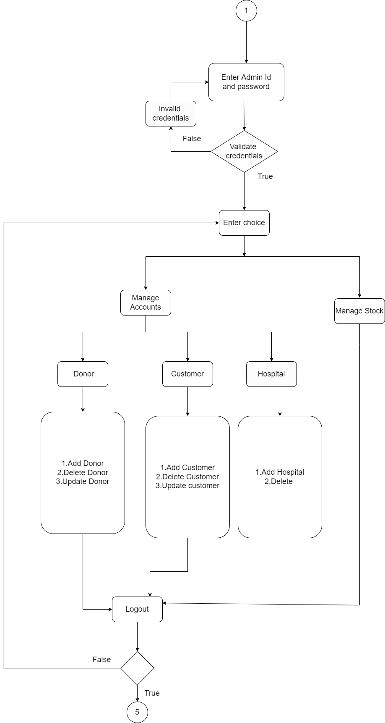

* 1. **Customer module:**

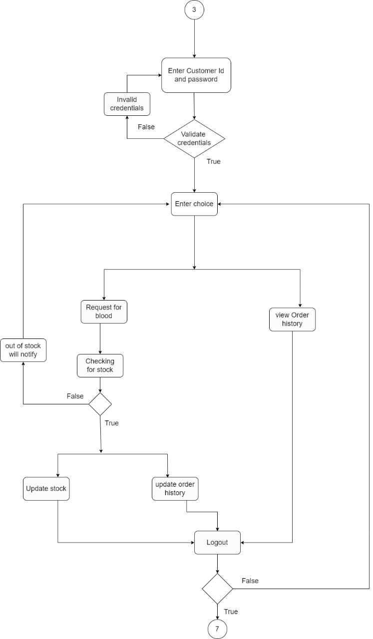

* 1. **Donor module:**

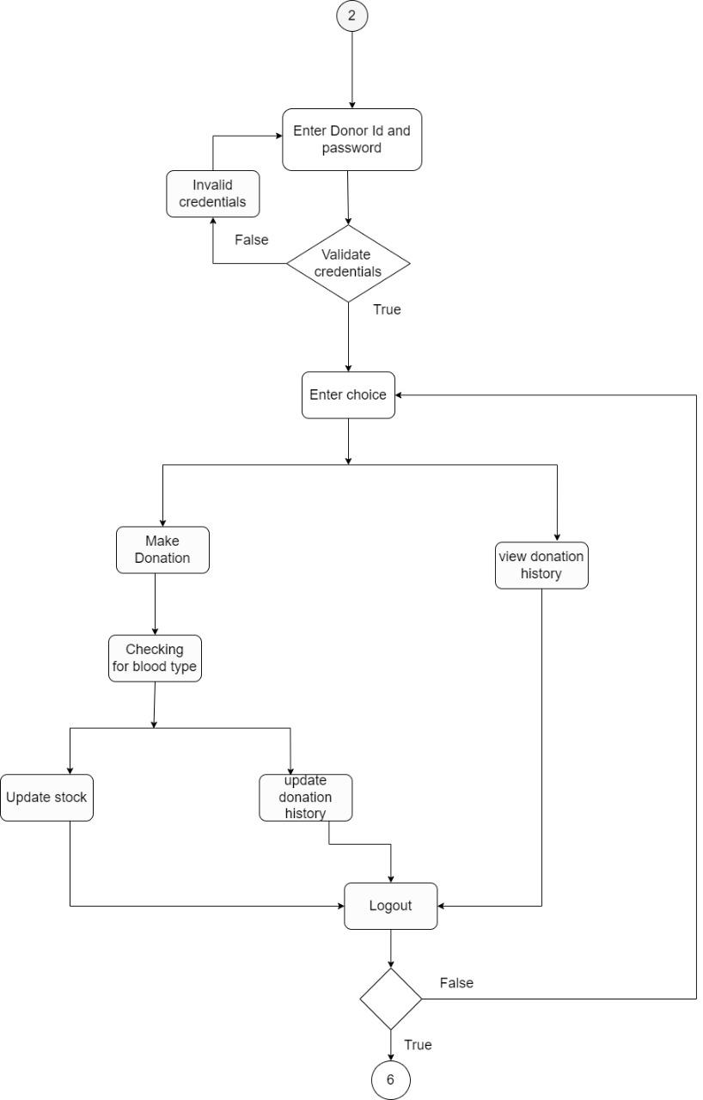

* 1. **Hospital module:**

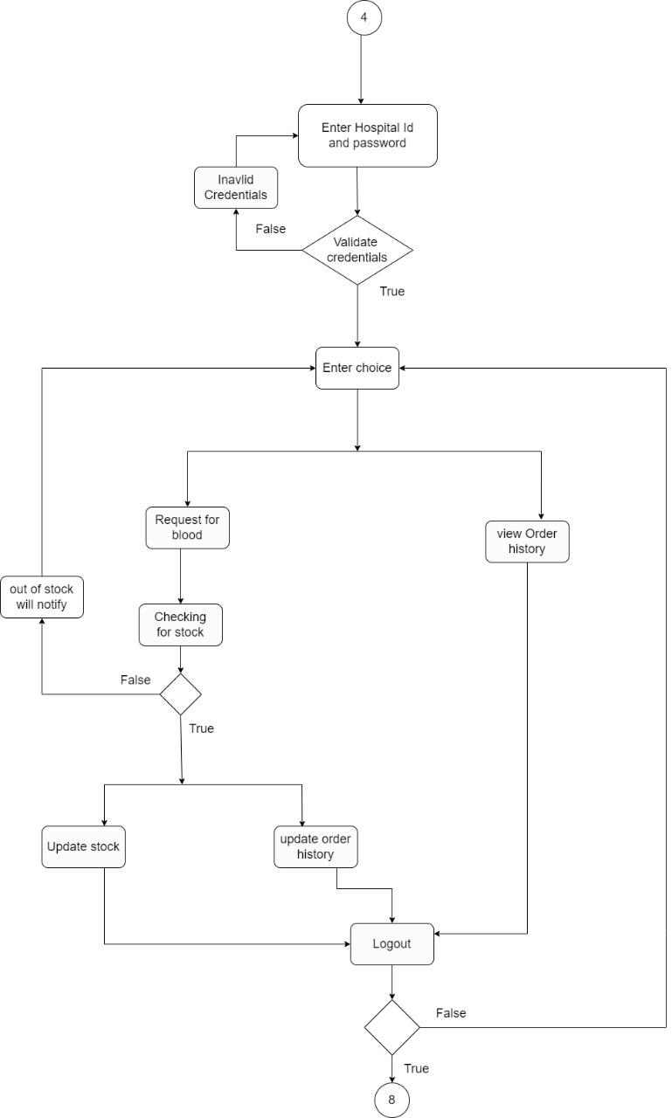

1. **Configuration files:**

| **Sl. No** | **File Name** | **Path** | **Description** |
| --- | --- | --- | --- |
| 1 | Admin_credentials.txt | ./DataBaseFiles | To store admin credentials |
| 2 | Customer_credentials.txt | ./DataBaseFiles | To store customer credentials |
| 3 | Donor_credentials.txt | ./DataBaseFiles | To store donor credentials |
| 4 | Hospital_credentials.txt | ./DataBaseFiles | To store hospital credentials |
| 5 | Customer_details.txt | ./DataBaseFiles | To store customer details |
| 6 | Donor_details.txt | ./DataBaseFiles | To store donor details |
| 7 | Hospital_details.txt | ./DataBaseFiles | To store hospital details |
| 8 | Stock.txt | ./DataBaseFiles | To store the details of blood in stock |
| 9 | Order_history.txt | ./DataBaseFiles | To store the order history of blood |
| 10 | Donation_history.txt | ./DataBaseFiles | To store donation history of blood |

1. **Limitation and Notes:**
2. Multi-threading is not applicable in this project.
3. **Revision history of the work Product:**

| **Date** | **Version** | **Author** | **Brief description of changes** |
| --- | --- | --- | --- |
| 22/09/2022 | 1.0 | Group1 | System Requirement Study (SRS) |
| 23/09/2022 | 1.0 | Group1 | Documentation part |
| 24/09/2022 | 1.0 | Group1 | ER diagram |
| 25/09/2022 | 1.0 | Group1 | Class diagram |
| 26/09/2022 | 1.0 | Group1 | Use case diagram |
| 28/09/2022 | 1.0 | Group1 | Activity diagram |
| 29/09/2022 | 1.0 | Group1 | Validations implementation |
| 30/09/2022 | 1.0 | Group1 | Deciding the test cases |
| 01/10/2022 | 1.0 | Group1 | Working on modules |
| 02/10/2022 | 1.0 | Group1 | Working on modules |
| 03/10/2022 | 1.0 | Group1 | Working on modules |
| 04/10/2022 | 1.0 | Group1 | Working on modules |
| 05/10/2022 | 1.0 | Group1 | Integration of all modules |
| 06/10/2022 | 1.0 | Group1 | Implementing the unit test cases |
| 07/10/2022 | 1.1 | Group1 | Making necessary modifications |